Questions:

- Why is decision tree accuracy so low?
- How is a decision tree pruned?
- Which measure selects the best attribute to split the records?
- List down some popular algorithms used for deriving Decision Trees along with their attribute selection measures.
- List down the attribute selection measures used by the ID3 algorithm to construct a Decision Tree.
- Briefly explain the properties of Gini Impurity.
- Which should be preferred among Gini impurity and Entropy?
- List down the different types of nodes in Decision Trees.
- What do you understand about Information Gain? Also, explain the mathematical formulation associated with it.
- Do we require Feature Scaling for Decision Trees? Explain.

Answer:

- Why is decision tree accuracy so low?
Decision tree accuracy is lower than what we would have expected. This can happen due to the following reasons: Bad data - It is very important to use the correct data for machine learning algorithms. Bad data can lead to wrong results. Randomness - Sometimes, the system is so complex that it is impossible to predict what will happen in future. In this case, the accuracy of the decision tree will drop as well. Overfitting - The decision tree may not be able to capture the uniqueness of the data, and so it can be considered as a generalization. If the same data is used to adjust the tree, it can over-fit the data.

- How is a decision tree pruned?
A decision tree is pruned using a branch and bound algorithm. A branch and bound algorithm find the optimal solution to the decision tree by iterating through the nodes of the tree and bounding the value of the objective function at each iteration. The objective function is the value of the decision tree to the business. At each node, the algorithm either removes a branch of the tree or prunes a branch to a new node. The best part is that a branch can be pruned even if it leads to a non-optimal solution.

- Which measure select the best attribute to split the records?
Attribute Selection Measures (ASM). Attribute selection measure is a heuristic for selecting the splitting criterion that partition data into the best possible manner. It is also known as splitting rules because it helps us to determine breakpoints for tuples on a given node. ASM provides a rank to each feature (or attribute) by explaining the given dataset.

- List down some popular algorithms used for deriving Decision Trees along with their attribute selection measures.
Some of the popular algorithms used for constructing decision trees are:
1. ID3 (Iterative Dichotomiser): Uses Information Gain as attribute selection measure.
2. C4.5 (Successor of ID3): Uses Gain Ratio as attribute selection measure.
3. CART (Classification and Regression Trees) – Uses Gini Index as attribute selection measure.

- List down the attribute selection measures used by the ID3 algorithm to construct a Decision Tree.
The most widely used algorithm for building a Decision Tree is called ID3. ID3 uses Entropy and Information Gain as attribute selection measures to construct a Decision Tree.
1. Entropy: A Decision Tree is built top-down from a root node and involves the partitioning of data into homogeneous subsets. To check the homogeneity of a sample, ID3 uses entropy. Therefore, entropy is zero when the sample is completely homogeneous, and entropy of one when the sample is equally divided between different classes.
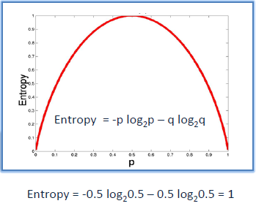
2. Information Gain: Information Gain is based on the decrease in entropy after splitting a dataset based on an attribute. The meaning of constructing a Decision Tree is all about finding the attributes having the highest information gain.
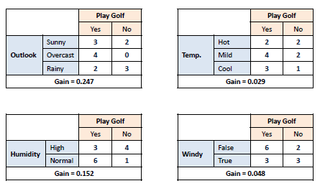
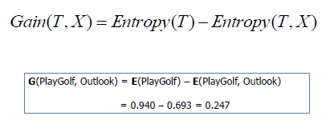

- Briefly explain the properties of Gini Impurity.
Let X (discrete random variable) takes values y₊ and y₋ (two classes). Now, let’s consider the different cases:
Case- 1: When 100% observations belong to y₊ . Then, the Gini impurity of the system would be: –
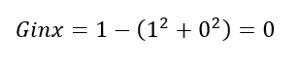
Case- 2: When 50% observations belong to y₊ . Then, the Gini impurity of the system would be: –
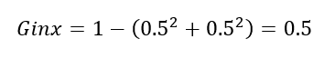
Case- 3: When 0% observations belong to y₊ . Then, the Gini impurity of the system would be: –
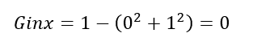
After observing all these cases, the graph of Gini impurity w.r.t to y₊ would come out to be:
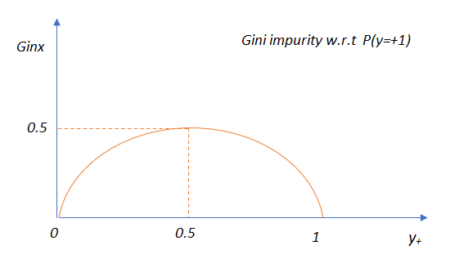

- Which should be preferred among Gini impurity and Entropy?
In reality, most of the time it does not make a big difference: they lead to almost similar Trees. Gini impurity is a good default while implementing in sklearn since it is slightly faster to compute.
However, when they work in a different way, then Gini impurity tends to isolate the most frequent class in its own branch of the Tree, while entropy tends to produce slightly more balanced Trees.

8. List down the different types of nodes in Decision Trees.
The Decision Tree consists of the following different types of nodes:
1. Root node: It is the top-most node of the Tree from where the Tree starts.
2. Decision nodes: One or more Decision nodes that result in the splitting of data into multiple data segments and our main goal is to have the children nodes with maximum homogeneity or purity.
3. Leaf nodes: These nodes represent the data section having the highest homogeneity.

9.What do you understand about Information Gain? Also, explain the mathematical formulation associated with it.
Information gain is the difference between the entropy of a data segment before the split and after the split i.e, reduction in impurity due to the selection of an attribute.
Some points keep in mind about information gain:
The high difference represents high information gain.
Higher the difference implies the lower entropy of all data segments resulting from the split.
Thus, the higher the difference, the higher the information gain, and the better the feature used for the split.

Mathematically, the information gain can be computed by the equation as follows:
Information Gain = E(S₁) – E(S₂)
– E(S₁) denotes the entropy of data belonging to the node before the split.
– E(S₂) denotes the weighted summation of the entropy of children nodes by considering the weights as the proportion of data instances falling in specific children nodes.

10. Do we require Feature Scaling for Decision Trees? Explain.
Decision Trees are mainly intuitive, easy to interpret as well as require less data preparation. In fact, they don’t require feature scaling or centering(standardization) at all. Such models are often called white-box models.
Decision Trees provide simple classification rules based on if and else statements which can even be applied manually if need be. For Example, Flower classification for the Iris dataset.

